Installing and Managing Packages
Demo
- API consumption example
- Data visualization example
Database Programming with Python
It refers to the process of connecting Python applications to databases in order to store, retrieve, modify, & manage persistent data.
In most applications, data must remain available even after the program terminates. Variables & objects stored in memory are temporary & are lost when the application stops. Databases solve this problem by providing permanent storage & efficient data management mechanism.
Python provides built-in & third-party libraries for interacting with different database systems:
- SQLite
- MySQL
- PostgreSQL
- Oracle
- Microsoft SQL Server
- MongoDB (NoSQL)
SQLite Introduction
What is SQLite?
SQLite is a lightweight, serverless, self-contained relational database management system. Unlike enterprise databases, SQLite does not need:
- Dedicated Database Servers
- Complex Configuration
- Separate installation of database services.
The entire database is stored in a single file on disk.
Characteristics of SQLite
- Serverless Architecture
- Self-Contained
- Lightweight
- Transaction Support
- Relational Database
Why SQLite is popular in Python?
It is commonly used because:
- Included with Python through the sqlite3 module.
- No separate installation required.
- Easy to learn.
- Suitable for small & medium-sized applications.
- Ideal for testing & prototyping.
Database Operations
- CREATE (Insert)
- READ (Select)
- UPDATE
- DELETE
Workflow for Database Interaction in Python
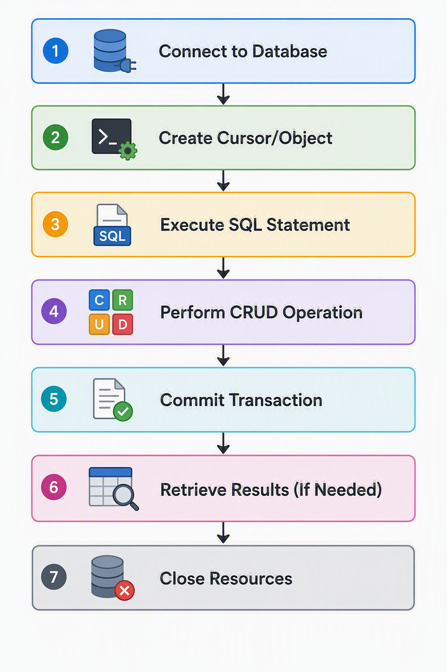
Python Database Connectivity
Demo
- Library Management System
Assignment
Student Information Management Requirements
The system should maintain the following information for every student:
Basic Information
- Student ID
- First Name
- Last Name
- Date of Birth
- Gender
Academic Information
- Course Name
- Department
- Semester
- Roll Number
- Enrollment Number
- Admission Date
Contact Information
- Email Address
- Mobile Number
- Residential Address
- City
- State
- Postal Code
Additional Information
- Guardian Name
- Guardian Contact Number
- Emergency Contact Number

Functional Requirements
Module 1: Student Registration
The system shall allow administrators to register new students.
Features
- Capture complete student details.
- Validate mandatory fields.
- Automatically assign a unique Student ID.
- Store information in the database.
- Prevent duplicate enrollment records.
Expected Outcome
A new student record should be successfully inserted into the database.

Module 2: View Student Records
The system shall provide functionality to view student information.
Features
- View all students.
- View detailed information for a specific student.
- Display records in a structured format.
- Show student count.
Expected Outcome
The administrator should be able to retrieve and review student records efficiently.

Module 3: Search Student Records
The system shall allow searching for students based on various criteria.
Search Criteria
- Student ID
- Student Name
- Roll Number
- Department
- Course
- Enrollment Number
Expected Outcome
The system should return all matching student records quickly and accurately.

Module 4: Update Student Information
Student records may change over time due to corrections or administrative updates.
Features
The administrator should be able to update:
- Student Name
- Contact Number
- Email Address
- Address
- Department
- Semester
- Course Information
Expected Outcome
The selected student record should reflect the modified information while preserving all other existing details.

Module 5: Delete Student Records
The system shall provide the ability to remove student records.
Features
- Delete a student by Student ID.
- Display confirmation before deletion.
- Remove the selected record permanently.
Expected Outcome
The specified student record should be removed from the database.

Module 6: Student Reporting
The system should generate basic reports that assist administrative decision-making.
Required Reports
Student List Report
Shows all registered students.
Department-wise Student Report
Displays students belonging to a selected department.
Course-wise Student Report
Displays students enrolled in a specific course.
Semester-wise Report
Displays students grouped by semester.
Student Count Report
Provides:
- Total students
- Students per department
- Students per course
Expected Outcome
Administrators should be able to obtain summarized information from stored records.

Database Requirements
Database Name
student_db.sqlite

Table Name
students
Suggested Database Schema
Primary Attributes
- student_id
- roll_number
- enrollment_number
Personal Attributes
- first_name
- last_name
- gender
- date_of_birth
Academic Attributes
- department
- course
- semester
- admission_date
Contact Attributes
- email
- mobile_number
- address
- city
- state
- postal_code

Database Operations to be Implemented
CREATE Operation
Purpose
Create the database and required tables.
Responsibilities
- Create the SQLite database file.
- Create the student table.
- Define constraints and data types.
- Establish primary keys.

INSERT Operation
Purpose
Add new student records.
Responsibilities
- Collect student information.
- Validate inputs.
- Store the data in the database.

SELECT Operation
Purpose
Retrieve student records.
Responsibilities
- View all records.
- Search specific students.
- Generate reports.

UPDATE Operation
Purpose
Modify existing records.
Responsibilities
- Identify record using Student ID.
- Update selected fields.
- Save modifications.

DELETE Operation
Purpose
Remove unwanted student records.
Responsibilities
- Identify record to remove.
- Confirm deletion.
- Permanently delete the record.

Menu-Driven Interface
The application should continuously display a menu until the user exits the system.
========================================
STUDENT DATABASE MANAGEMENT SYSTEM
========================================

1. Register New Student
2. View All Students
3. Search Student by ID
4. Search Student by Name
5. Update Student Information
6. Delete Student Record
7. Department-wise Report
8. Course-wise Report
9. Student Count Report
10. Exit

Enter Your Choice:
Expected Deliverables
The final solution should include:
- SQLite Database Creation
- Student Table Creation
- Python Database Connectivity
- CRUD Functionality
- Search Functionality
- Report Generation
- Menu-Driven Interface
- Exception Handling
- Input Validation
- Proper Documentation

Learning Outcomes
Upon successful completion of this project, learners will be able to:
- Understand database programming using Python.
- Work with SQLite databases.
- Establish database connections.
- Create and manage database tables.
- Execute SQL queries from Python.
- Perform CRUD operations.
- Build real-world database-driven applications.
- Generate reports using database records.
- Implement error handling and validation techniques.
- Design scalable database solutions for business applications.
This project closely resembles real-world systems used in schools, colleges, universities, training institutes, and educational organizations for managing student information efficiently and securely.

